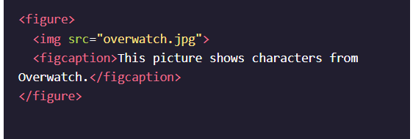

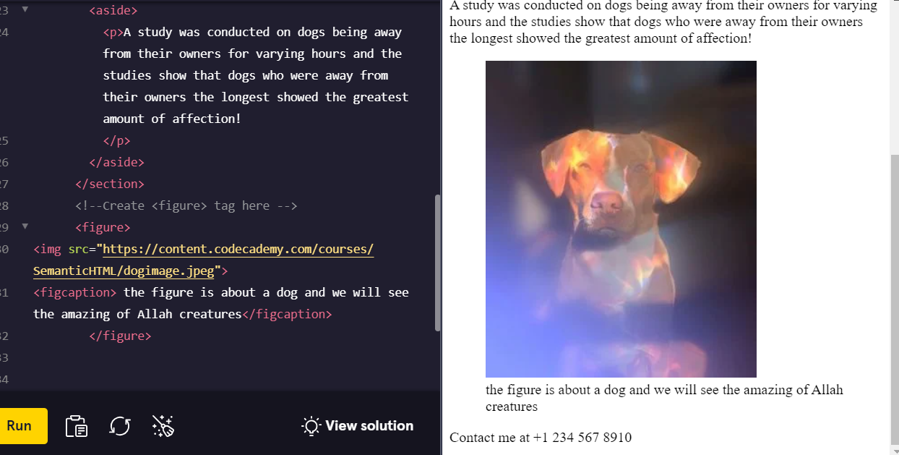

<!DOCTYPE html>

<html>

  <body>

    <header>

      <h1>Navigational Links</h1>

      <nav>

        <ul>

          <li><a href="#home">Home</a></li>

          <li><a href="#posts">Posts</a></li>

          <li><a href="#contact">Contact</a></li>

        </ul>

      </nav>

    </header>

    <main>

      <section>

        <article>

          <h2>Facts About Dogs</h2>

          <p>

          Dogs have a sense of time. It's been proven that they know the difference between a hour and five. If conditioned to, they can predict future events, such as regular walk times.

          </p>

        </article>

        <aside>

          <p>A study was conducted on dogs being away from their owners for varying hours and the studies show that dogs who were away from their owners the longest showed the greatest amount of affection!

          </p>

        </aside>

      </section>

      <figure>

        <img src="https://content.codecademy.com/courses/SemanticHTML/dogimage.jpeg"/>

        <figcaption>A cute dog.</figcaption>

      </figure>

       <!-- Create <audio> tag here -->

      <audio autoplay controls>

        <source src="https://content.codecademy.com/courses/SemanticHTML/dogBarking.mp3" type="audio/mp3">

        </audio>

    </main>

    <footer>

      <p>Contact me at +1 234 567 8910 </p>

    </footer>

  </body>

</html>

**Review**

<1 min

Congrats on completing this lesson on Semantic HTML! Now that you know the benefits of Semantic HTML and how to use it, you can incorporate semantic elements into your website to make it more accessible and to make the code easier to read.

Let’s review some of the topics we covered throughout the lesson:

* Semantic HTML introduces meaning to a page through specific elements that provide context as to what is in between the tags.
* Semantic HTML is a modern standard and makes a website accessible for people who use screen readers to translate the webpage and improves your website’s SEO.
* <header>, <nav> , <main> and <footer> create the basic structure of the webpage.
* <section> defines elements in a document, such as chapters, headings, or any other area of the document with the same theme.
* <article> holds content that makes sense on its own such as articles, blogs, comments, etc.
* <aside> contains information that is related to the main content, but not required in order to understand the dominant information.
* <figure> encapsulates all types of media.
* <figcaption> is used to describe the media in <figure>.
* <video>, <embed>, and <audio> elements are used for media files.

Now, apply this knowledge to become a better Web Developer.

Ordered list is numbers

    <h1> An Insider’s Guide to <a href="https://en.wikipedia.org/wiki/New_York_Fashion_Week." target="_blank"> NYFW” </h1>

If using a target =”_blank” will open to new tab

<!DOCTYPE html>

<html>

<head>

 <title> Everyday with Isa </title>

  <body>

    <a href=#contact>

    <img src="https://content.codecademy.com/courses/le

arn-html/elements-and-

structure/profile.jpg" alt="profile picture"></img>

</a>

<h3> “by Isabelle Rodriguez | 1 day ago” </h3>

    <h1> An Insider’s Guide to <a href="https://en.wikipedia.org/wiki/New_York_Fashion_Week." target="_blank"> NYFW” </h1> </a>

    <img src="https://content.codecademy.com/courses/le

arn-html/elements-and-structure/image-

one.jpeg"></img>

<p>“NYFW can be both amazingly fun & incredibly overwhelming, especially if you’ve never been. Luckily, I’m here to give you an insider’s guide and make your first show a pleasurable experience. By taking my tips and tricks, and following your gut, you’ll have an unforgettable experience!”</p>

    <img src="https://content.codecademy.com/courses/le

arn-html/elements-and-structure/image-

two.jpeg"></img>

<p>“If you’re lucky or connected you can get an invite, sans the price tag. But I wasn’t so lucky or connected my first 2 years so I’m here to help you out. First, plan out which shows are most important to you and make a schedule and this is a biggie: SET A BUDGET. If you’re worrying about blowing your cash the whole time you won’t have fun. Then check out prices, days, and times and prioritize the designers you want to see most. Lastly, purchase your tickets and get excited!”</p>

 <h2> Getting Tickets & Picking the Shows</h2>

   <img src="https://content.codecademy.com/courses/le

arn-html/elements-and-structure/image-

three.jpeg"></img>

<p>“Always be true to your own sense of style, if you don’t you’ll be uncomfortable the whole time and it will show. Remember, NYFW is about expressing yourself and taking in what the designers have chosen to express through their new lines. Also it’s important to wear shoes you’ll be comfortable in all day. Obviously you want to look good, but you’ll be on your feet all day long, so be prepared.”</p>

<h4>  “Related Content” </h4>

<ul>

  <li>“How To Style Boyfriend Jeans”</li>

<li>“When Print Is Too Much”</li>

<li>“The Overalls Trend”</li>

<li>“Fall’s It Color: Blush”</li>

</ul>

 <h2> “Dressing for the Shows” </h2>

  </body>

  <div id='contact'>

    <p> <strong>email: isa@fashionblog.com | phone: 917-555-1098 | address: 371 284th St, New York, NY, 10001</strong></p>

    </div>

   </head>

  </html>

